|  |  |  |  |  |  |
| --- | --- | --- | --- | --- | --- |
| Date | 1-Dec-22 | | | Tester Name | Mayuri Patel |
| Environment | Penfax - Test | | | Login used |  |
| Operating System | Select OS | Version: | Update: | | |
| Software Used | Select Software | Version: | Update: | | |
| Select Software | Version: | Update: | | |
| Release version | 22.4.1 | | | | |
| Title |  | | | | |
| Test Type | Regression | | | | |
| Test Scenario | Set up minimum payments someone age 72 or older | | | | |
|  |  | | | | |
| Expected Results |  | | | | |
| Pass/Fail | Pass | | | JIRA# | N/A |

Describe your steps with screenshots:

Find a member who is 72 or older and not having ITA minimum active

Open that member profile

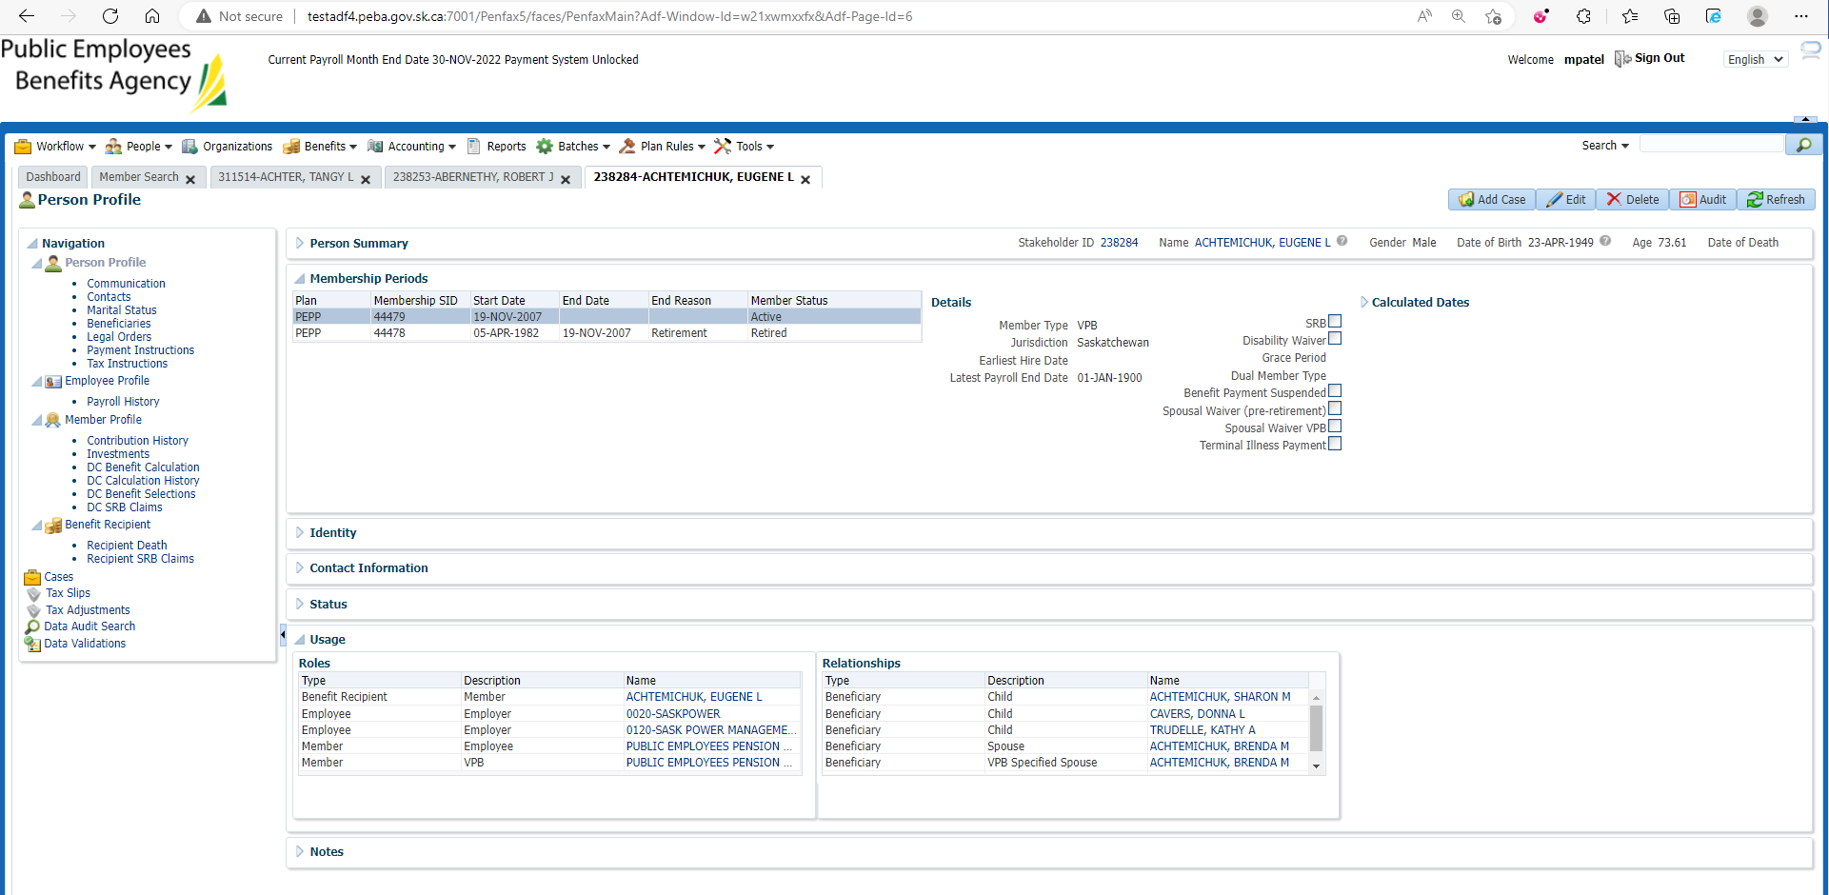

Investments🡪 Account instructions

Add Account Instruction

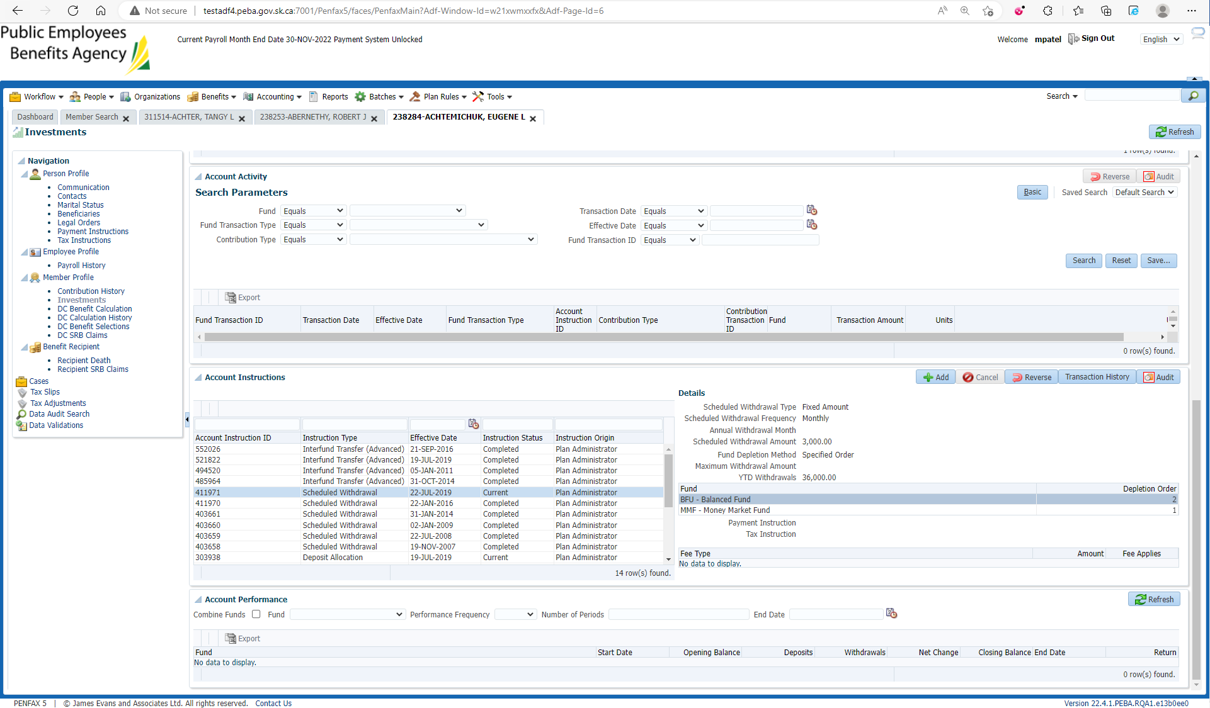

Enter scheduled withdrawal type to ITA minimum and other mandatory details and Save

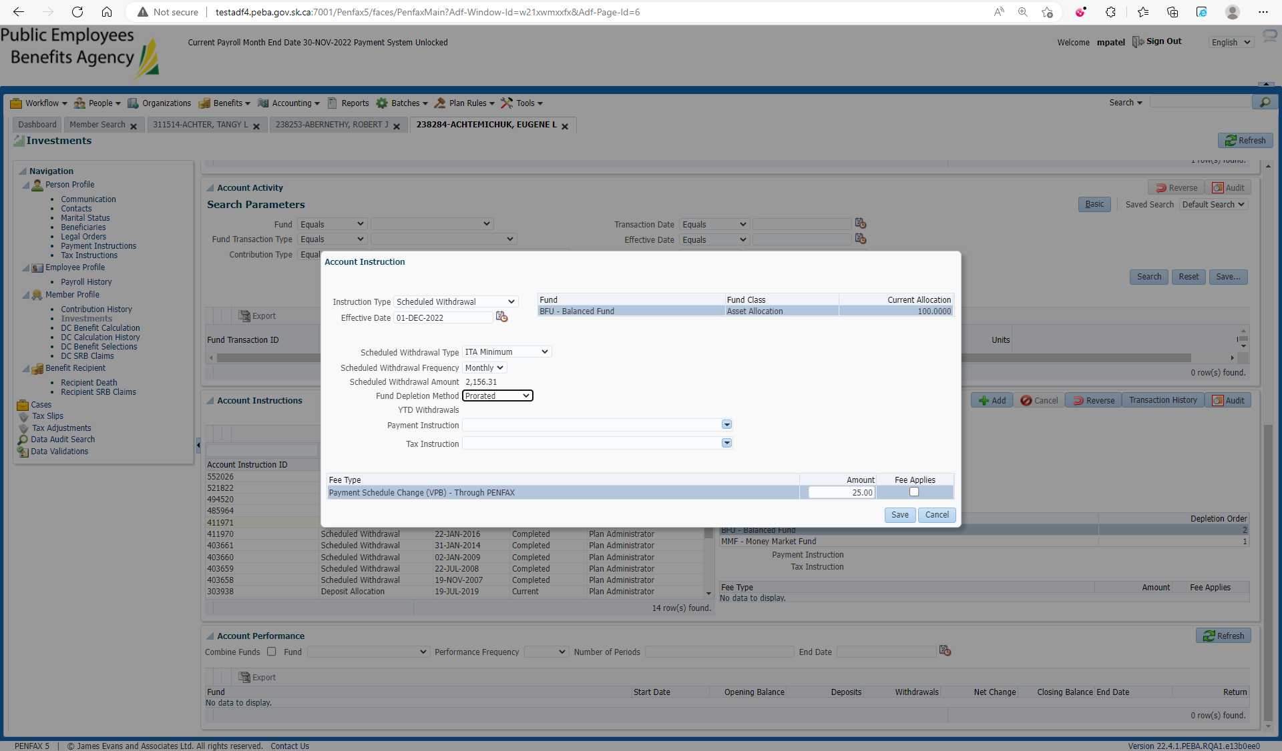

Newly added account Instruction is now current and previous one is completed

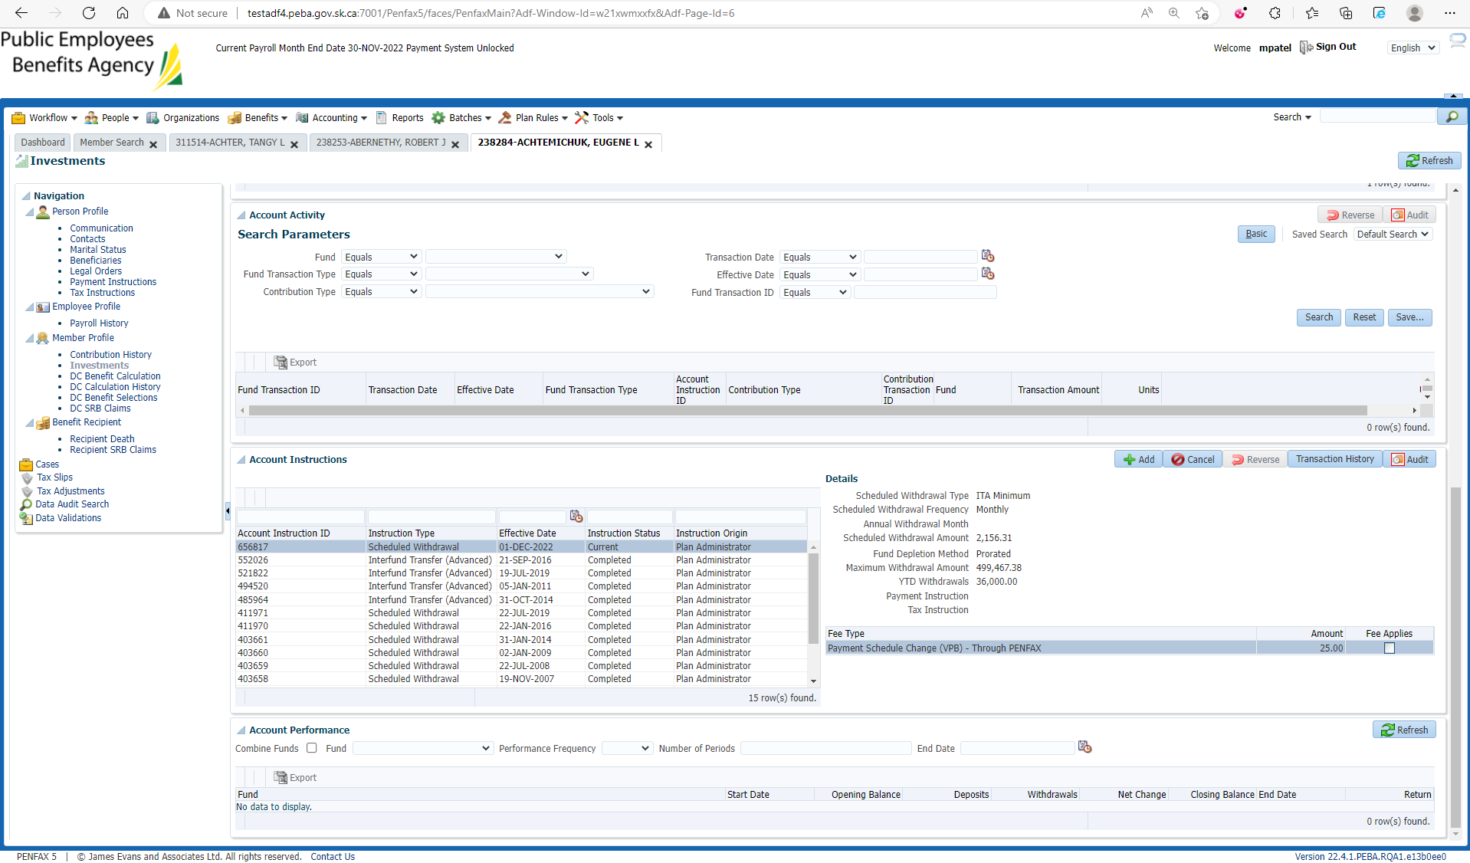

Same steps processed through Penweb

